**INVESTMENT REALTY**

**301 Water Street · Eau Claire, WI 54703 · 715-832-0022**

303

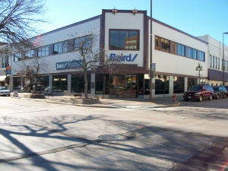

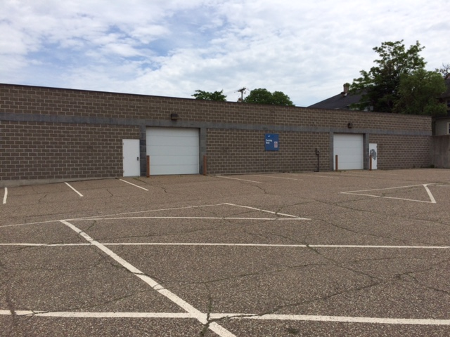

**215 S. Dewey Street**

* Warehouse Space
* 2 overhead doors
* Space includes single bath & one office
* $2,900/MTH for 9,316 Sq ft
* Space can be divided into two spaces
* Extra parking available

**306 South Barstow Street**

* 17,000 Sq ft available
* Located on 2nd floor of building
* Price negotiable

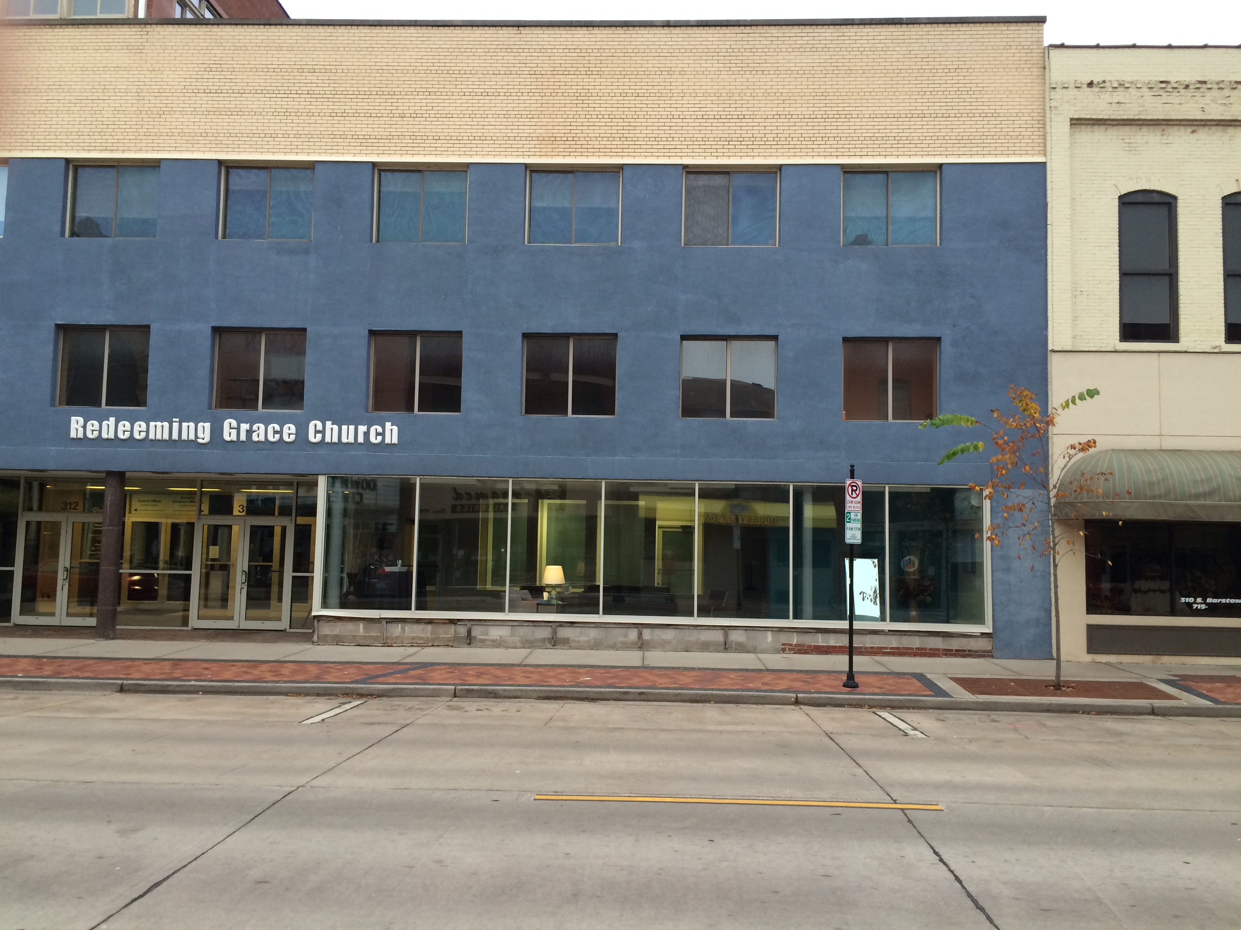

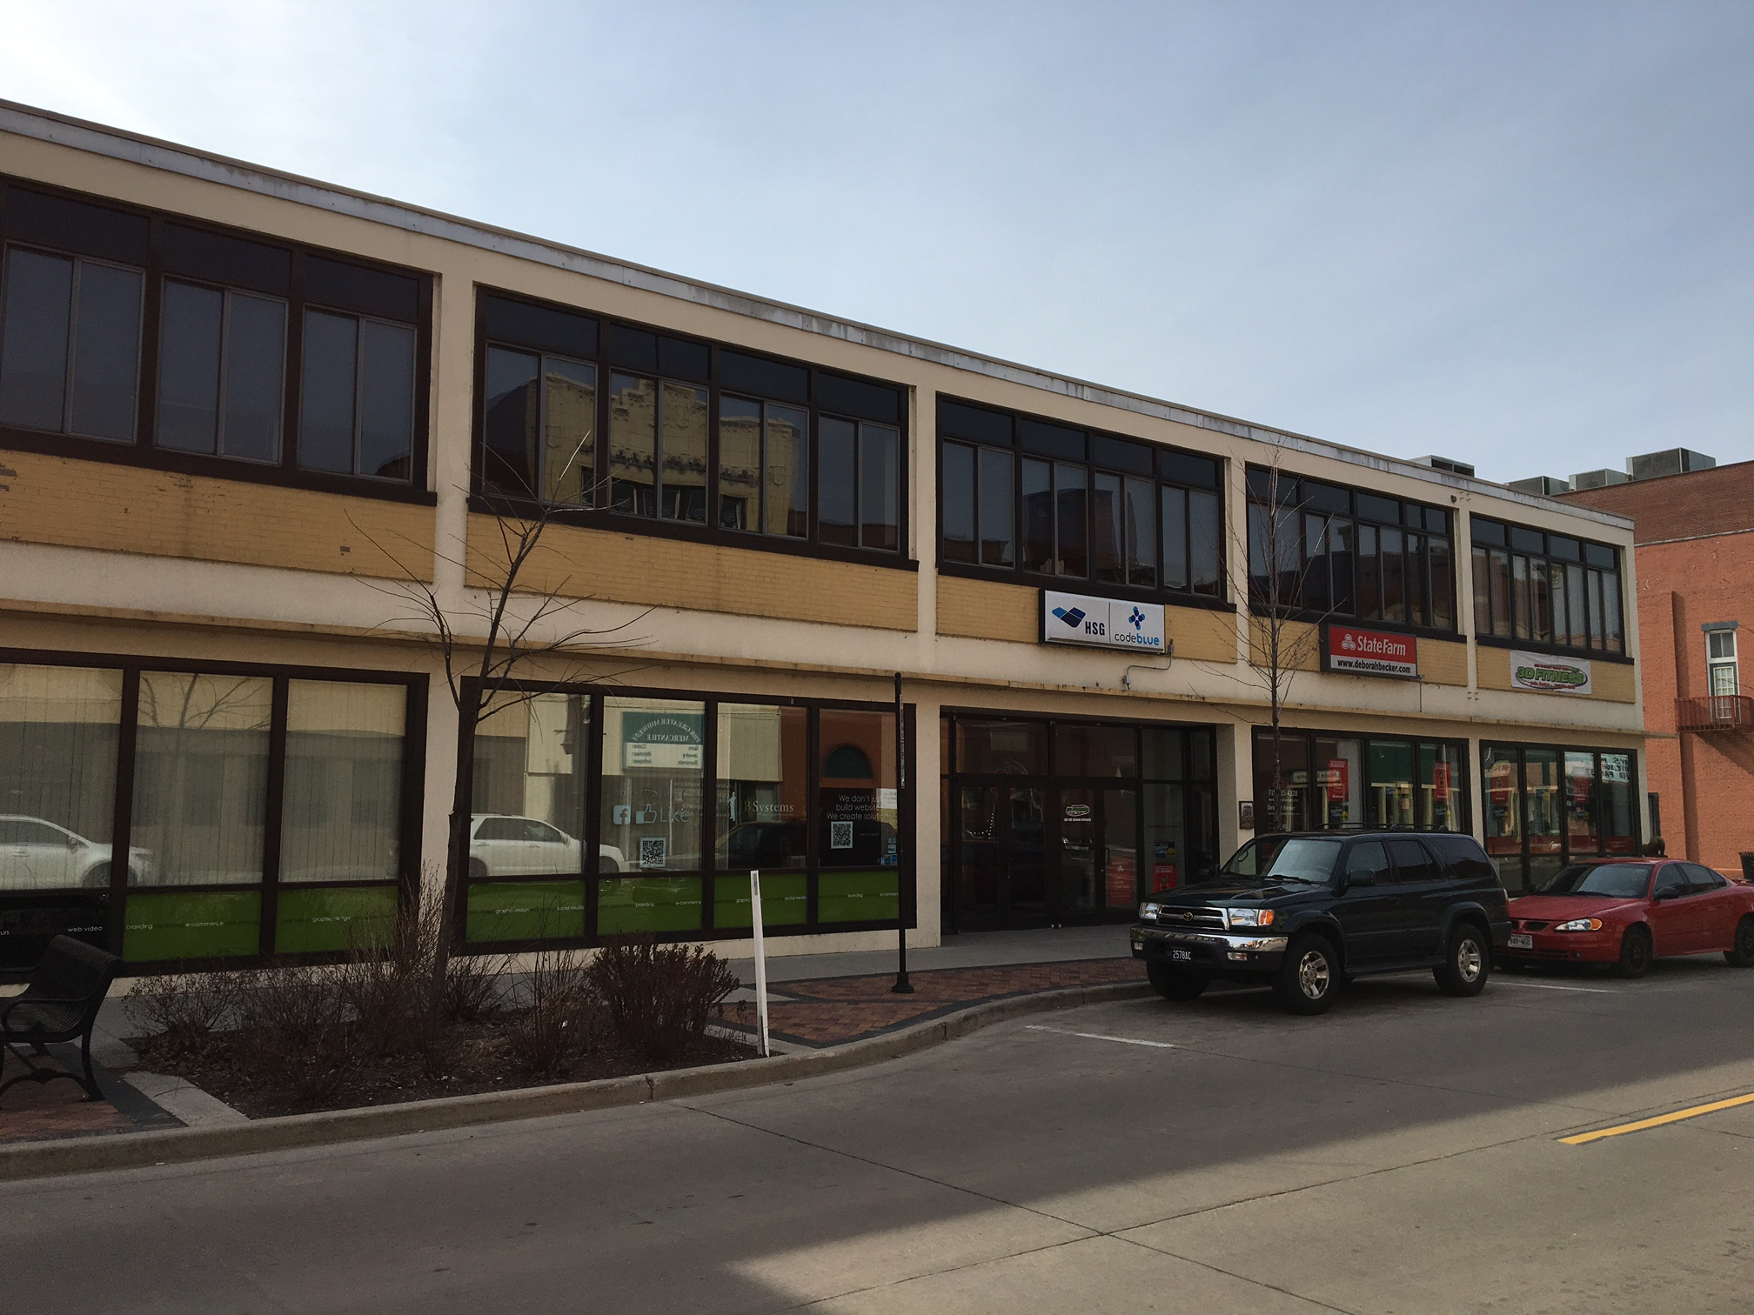

**404 South Barstow Street Lower Level**

* 1,855 Sq ft
* All utilities included
* High Ceilings
* Common lunch room area, shower and restrooms
* $1,550/month

**312 South Barstow Street**

* Office space available on 2nd floor
* Various square foot options
* 3,500 Sq ft is $3,000 per month
* 5,136 Sq ft is negotiable
* 8,636 Sq ft is negotiable

**Visit our website at** [**www.investmentrealtors.com**](http://www.investmentrealtors.com) **for additional information**

303

**INVESTMENT REALTY**

**301 Water Street · Eau Claire, WI 54703 · 715-832-0022**

303

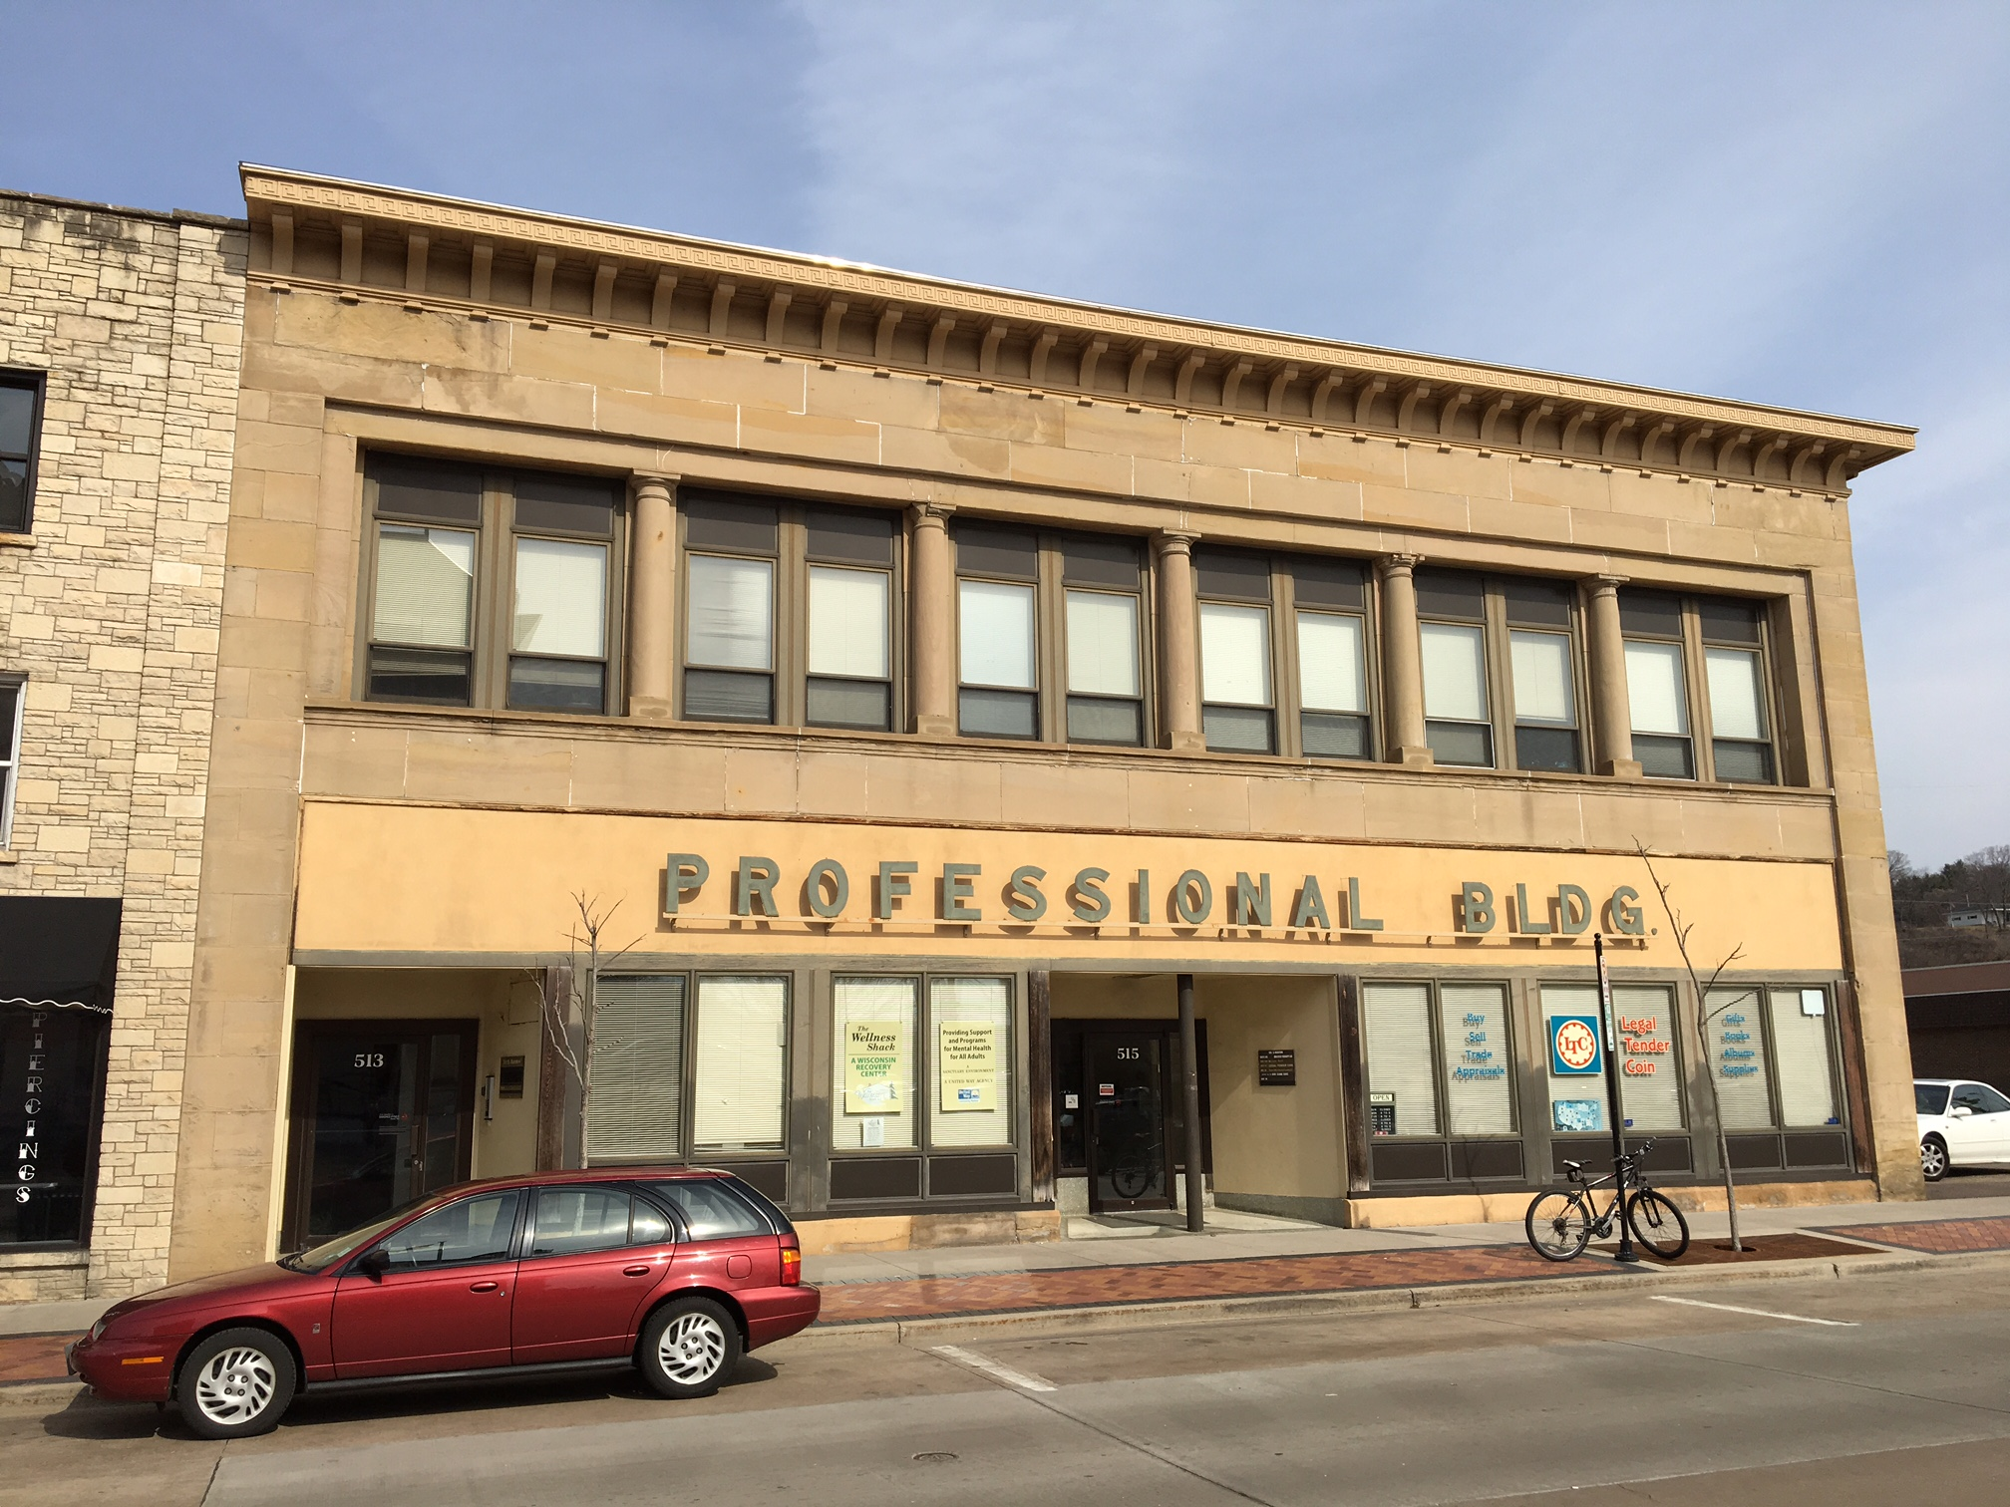



**515 South Barstow Street, Suite #110**

* Approximately 1326 Sq ft
* Wide open space
* Price Negotiable

**515 South Barstow Street, Suite #116**

* Approximately 1500 Sq ft
* Wide open space
* Price Negotiable





**515 South Barstow Street, Suite #117**

* Approximately 800 Sq ft
* Wide open space
* Price Negotiable

**404 South Barstow Street**

* Approximately 2800 sq. ft.
* $2,000/month
* Common lunch room area and bathrooms

**Visit our website at** [**www.investmentrealtors.com**](http://www.investmentrealtors.com) **for additional information**

303